Student Performance Analysis and Prediction Using Machine Learning

A report submitted in partial fulfillment of the requirements for the Award of
Degree of
BACHELOR OF TECHNOLOGY
in
ARTIFICIAL INTELLIGENCE & MACHINE LEARNING

Submitted by

RAYAPUDI HARSHA VARDHANI
Y22ACM467


Department of AIML
Bapatla Engineering College
(Autonomous)
Affiliated to Acharya Nagarjuna University, Guntur
Bapatla-522102
2025

CERTIFICATE
This is to certify that the Internship report entitled “Student Performance Analysis and Prediction Using Machine Learning” being submitted by “RAYAPUDI HARSHA VARDHANI” “Y22ACM467 “is work done by him/ her and submitted during 2024– 2025 academic year, in partial fulfillment of the requirements for the award of the degree of BACHELOR OF TECHNOLOGY in AIML, at “SkillDzire in Hyderabad” from 05th May, 2025 and to 20th June, 2025

Department Internship Coordinator Head of the Department

DECLARATION

I hereby declare that the dissertation entitled Student Performance Analysis and Prediction Using Machine Learning submitted for the B.Tech Degree is my work and the dissertation has not formed the basis for the award of any degree, associates, fellowship or any other similar titles.

Place: Bapatla R.HARSHA VARDHANI
Date:06-10-2025 Y22ACM467

INTERSHIP CERTIFICATE ISSUED BY COMPANY


COMPANY PROFILE AND EXTERNAL GUIDE DETAILS
COMPANY PROFILE:
SkillDzire Technologies Pvt. Ltd. is a Hyderabad-based edtech organization established in 2020 with a mission to bridge the gap between academic learning and industry requirements through hands-on skill development. The company focuses on providing real-time, project-based training and virtual internship programs for students and professionals across diverse engineering and management domains. Its learning ecosystem offers courses in areas such as Artificial Intelligence, Machine Learning, Data Science, Embedded Systems, IoT, Civil and Mechanical Design, Digital Marketing, and more. SkillDzire collaborates with industry experts and academic institutions to design training modules that combine theoretical understanding with practical exposure, ensuring learners gain job-ready skills. Through online and offline learning models, the company emphasizes interactive sessions, assessments, live projects, and certification support. With its vision of creating a skill-oriented learning culture, SkillDzire aims to empower learners to become industry-ready professionals and contribute to the evolving technological landscape.
External Guide Lines:
The external guide plays a crucial role in mentoring and evaluating students during their internship at SkillDzire Technologies Pvt. Ltd. The guide, representing the company, provides technical and professional supervision throughout the training period. They help students understand real-time industrial practices, assign project tasks, monitor progress, and assess performance based on skill development and project outcomes. The external guide ensures that the internship objectives align with industry standards and that students gain practical exposure relevant to their academic field. Through continuous guidance and feedback, the external guide contributes significantly to bridging the gap between theoretical knowledge and its real-world application.

ACKNOWLEDGMENTS
I would like to express my sincere gratitude to SkillDzire Technologies Pvt. Ltd. for providing me with the opportunity to undertake my internship and gain valuable practical experience. I am deeply thankful to my external guide at SkillDzire for their constant guidance, support, and encouragement throughout the training period. Their insightful feedback and mentorship helped me enhance my technical and professional skills. I would also like to extend my heartfelt thanks to my faculty guide and my institution for their continuous support and for giving me the chance to connect academic learning with real-world applications. Finally, I am grateful to all team members and mentors at SkillDzire for their cooperation, patience, and valuable insights that made this internship a truly enriching experience.
ABSTRACT:
The project focuses on predicting student academic performance using machine learning techniques, aiming to provide data-driven insights that can help educators support at-risk students. The study analyzes key factors influencing academic outcomes, including study hours, attendance, class participation, and total scores. Various machine learning models, such as Linear Regression, Random Forest, and Gradient Boosting, were implemented and evaluated for their predictive performance. Among these, the Random Forest model achieved the highest accuracy in predicting final grades, demonstrating its effectiveness in handling complex educational datasets. The system provides a practical approach for early identification of students who may require additional support, enabling timely interventions and promoting improved academic performance.

PROPOSED SYSTEM:
- Uses Machine Learning algorithms to predict student performance.
- The system studies many factors like study time, attendance, previous grades, and family background.
- It gives a data-based and accurate prediction of student results.
- Helps teachers identify weak students early and give extra support.
- Saves time and reduces manual work for teachers.
- Shows graphs and charts to understand performance easily.
- Overall, it makes the evaluation process smart, fast, and effective.

TABLE OF CONTENTS

S.No | CONTENTS | PageNo.
1. | Introduction | 9
2. | Existing System For Student Performance Analysis And Predicition using Machine learning | 10-11
3. | Software Requirement Analysis For Student Performance Analysis And Predicition using Machine learning | 11-14
4. | Software Design For Student Performance Analysis And Predicition using Machine learning | 15-16
5. | Technology and Methodoloy | 17-18
6. | Coding For Student Performance Analysis And Predicition using Machine learning | 19-22
7. | Output Screen/Result | 23-27
8. | Conclusion | 27
9. | Reference | 28

- Introduction:
In today’s educational environment, understanding the factors that affect student performance is very important. Students’ grades can be influenced by many factors, such as study hours, attendance, participation in class, and other academic habits. By analyzing these factors, educators can identify students who may need extra support and help them improve their performance. This project uses machine learning techniques to predict how students will perform academically. Machine learning allows computers to learn patterns from past data and make predictions about future outcomes. By applying models like Linear Regression, Random Forest, and Gradient Boosting, this project predicts students’ final grades and helps teachers make data-driven decisions to support at-risk students.

Objective:
The main objectives of this project are:
- To analyze the key factors affecting student academic performance, such as study hours, attendance, participation, and total scores.
- To apply different machine learning models to predict students’ final grades.
- To identify which machine learning model provides the most accurate prediction.
- To provide insights that can help educators recognize students who may need additional support.
- To assist in making data-driven decisions that improve student learning and performance.
2.Existing System For Student Performance Analysis And prediction Using Machine Learning:
Description:
In the existing system, student performance is usually evaluated based on manual observation, periodic tests, and final exam scores. Teachers rely on attendance records, class participation, and exam results to identify students who may be struggling.
Existing system :
- Exam-Based Evaluation: Student performance is assessed primarily through exam marks.
- Manual Assessment: Teachers evaluate students manually without the support of any data analysis tools.
- Time-Consuming: The evaluation process takes more time and effort due to manual handling of records.
- Subjective Opinion: Performance assessment depends on the teacher’s personal judgment, which may not always be accurate.
- Limited Factors Considered: Important factors like study hours, attendance, participation, and family background are not taken into account.
- Delayed Identification of Weak Students: Teachers cannot easily identify students who need extra help at an early stage.
- Overall Inefficiency: The system is manual, slow, and less effective in providing a complete understanding of student performance.

System Flow:
- Student Attends Classes:Students attend lectures and participate in classroom activities.
- Teacher Monitors Students:Teachers observe students’ behavior, participation, and attendance manually.
- Conduct Examinations:Periodic tests and final exams are conducted to assess student knowledge.
- Manual Evaluation:Teachers manually check exam papers, assignments, and projects to evaluate performance.
- Performance Assessment:Grades are assigned based only on exam marks and teacher observations
- Report Generation:Student performance reports are created manually and shared with students.

Existing system Implementation:
In the existing system, student performance is evaluated manually by teachers without using any automated tools or software. Teachers primarily rely on exam marks, assignments, and classroom observations to assess students. The evaluation process involves collecting exam papers, grading them by hand, and recording the results in registers or spreadsheets. Important factors like study hours, attendance, class participation, or family background are generally not considered.
This manual approach is time-consuming and subjective, as it depends on the teacher’s judgment. There is no mechanism to predict future student performance or to identify students who may be at risk at an early stage. As a result, interventions are often delayed, and the system is less effective in improving academic outcomes.
3.Software Requirements Student Performance Analysis And Prediction Using Machine Learning
Functional Requirements:
Functional requirements describe what the system should do.
They include:
- Data Collection: Ability to input or import student data such as study hours, attendance, participation, and exam scores.
- Data Preprocessing: Cleaning and organizing the data to make it suitable for analysis.
- Model Implementation: Apply machine learning algorithms such as Linear Regression, Random Forest, and Gradient Boosting.
- Prediction: Predict the final academic performance or grades of students.
- Model Evaluation: Evaluate the accuracy and performance of different machine learning models.
- Result Visualization: Display predictions, charts, or graphs to help understand student performance trends.
- Report Generation: Generate summaries or reports highlighting at-risk students for educator intervention.
Non-functional Requirements
Non-Functional requirements describe how the system performs. These include:
- Performance:The system should provide predictions quickly and efficiently, even for large datasets.
- Accuracy: Machine learning models must provide reliable predictions with minimum error.
- Usability: The interface should be simple and easy to use for teachers and
administrators.
- Scalability: The system should handle increasing amounts of student data without performance degradation.
- Maintainability: Th e system should be easy to update with new data or improved models.
- Security: Student data should be stored securely, ensuring privacy and restricted access.
- Portability: The software should work on multiple platforms, such as Windows or web-based applications.
System Requirements:
1. Hardware Requirements:
- Processor: Minimum Intel Core i3; Recommended Intel Core i5 or higher
- RAM: Minimum 4 GB; Recommended 8 GB or higher
- Storage: Minimum 250 GB HDD; Recommended 500 GB SSD
- Display: Minimum 14-inch monitor; Recommended 15-inch or higher
- Graphics: Integrated Graphics; Dedicated Graphics Card optional
- Input Devices: Keyboard and Mouse
- Internet Connection: Required for accessing datasets; high-speed recommended

2. Software Requirements:
- Operating System: Windows 10 or above, Linux, or macOS
- Programming Language: Python
- Libraries / Frameworks: Scikit-learn (Machine Learning),Pandas, NumPy (Data handling),Matplotlib, Seaborn (Data Visualization)
- Database: QLite, MySQL, or CSV files for storing student data
- Development Tools / IDE: Jupyter Notebook, PyCharm, or VS Code
- GUI / Web Tools : Streamlit or Tkinter for building interactive dashboards

4.Software Design For Student performance Analysis And perdiction using Machine learning
Software design describes how the system is structured and how different components interact to achieve the project objectives. The design focuses on the flow of data, the logic of the system, and the implementation of machine learning models for predicting student performance.
1. Architecture:
- The system follows a modular architecture with separate modules for data collection, preprocessing, model training, prediction, and result visualization.
- Data Input Module: Accepts student data including study hours, attendance, participation, and exam scores.
- Preprocessing Module: Cleans the data, handles missing values, and prepares it for analysis.
- Model Training Module: Implements machine learning algorithms like Linear Regression, Random Forest, and Gradient Boosting.
- Prediction Module: Uses the trained models to predict final grades of students.
- Evaluation Module: Compares model predictions with actual results to measure accuracy.
- Visualization & Reporting Module: Generates charts, graphs, and reports to help educators identify at-risk students.
2. Data Flow:
- Student data is collected and stored in a structured format (CSV/Database).
- Preprocessing cleans and normalizes the data.
- Machine learning models are trained using historical data.
- Predictions are made on current student data.
- Results are evaluated, and the best-performing model is selected.
- Reports and visualizations are generated for educators to take action.
3. Tools and Technologies Used:
- Programming Language: Python
- Machine Learning Libraries: Scikit-learn
- Data Handling: Pandas, NumPy
- Visualization: Matplotlib, Seaborn
- GUI/Interactive Dashboard: Streamlit or Tkinter
4. Advantages of the Design:
- Modular design allows easy updates or addition of new models.
- Data-driven approach ensures accurate predictions.
- Visualization helps educators take quick and informed decisions.
- System can handle increasing student data efficiently.
Flow Chart:
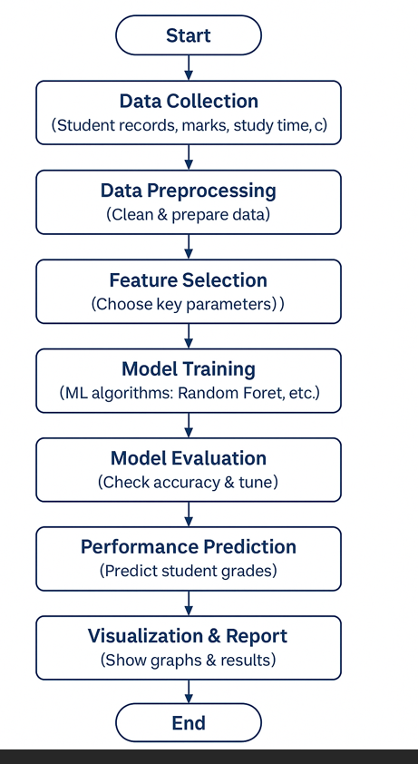

5.Technology and Methodology For Student Performance
Anlaysis And Prediction Using Machine Learning
1. Technology Used:
The project leverages modern technologies and tools to implement a predictive system:
- Programming Language: Python – widely used for data analysis and machine learning.
- Machine Learning Libraries:
  - Scikit-learn: For implementing algorithms like Linear Regression, Random Forest, and Gradient Boosting.
  - Pandas & NumPy: For data manipulation, cleaning, and preprocessing.
- Data Visualization Tools: Matplotlib and Seaborn for charts and graphical representation of results.
- Database / Data Storage: CSV files, SQLite, or MySQL for storing student data.
- GUI / Interactive Dashboard (Optional): Streamlit or Tkinter to make the system user-friendly for educators.

2. Methodology:
The project follows a structured methodology to predict student performance using machine learning:
- Data Collection:
  - Gather student data including study hours, attendance, class participation, and previous exam scores.
- Data Preprocessing:
  - Clean the data by handling missing values and outliers.
  - Normalize and standardize features to prepare for model training.
- Feature Selection:
  - Identify important factors that influence student performance.
  - Reduce redundant or irrelevant features to improve model accuracy.
- Model Selection and Training:
  - Apply machine learning models such as Linear Regression, Random Forest, and Gradient Boosting.
  - Split data into training and testing sets to evaluate performance.
- Prediction:
  - Use trained models to predict final grades of students.
- Model Evaluation:
  - Evaluate models using accuracy, mean squared error (MSE), and other metrics to choose the best-performing model.
- Visualization and Reporting:
  - Generate graphs, charts, and reports to present results.
  - Highlight at-risk students for timely intervention by educators.

6.Coding For Student Performance Analysis and Prediction Using Machine Learning
# 🎓 STUDENT PERFORMANCE ANALYSIS & PREDICTION SYSTEM
import streamlit as st
import pandas as pd
import numpy as np
import seaborn as sns
import matplotlib.pyplot as plt
from sklearn.model_selection import train_test_split
from sklearn.preprocessing import StandardScaler
from sklearn.linear_model import LinearRegression
from sklearn.ensemble import RandomForestRegressor, GradientBoostingRegressor
from sklearn.metrics import r2_score, mean_squared_error
# ---- Streamlit Page Setup ----
st.set_page_config(page_title="Student Performance Prediction", page_icon="🎓", layout="wide")
st.title("🎓 Student Performance Analysis & Prediction System")
st.markdown("---")
# ---- Load Dataset ----
st.subheader("📂 Step 1: Load Dataset")
data = pd.read_csv(r"C:\Users\harsh\Downloads\archive (1).zip")
st.success("✅ Dataset successfully loaded!")
st.dataframe(data.head())
# ---- Data Preprocessing ----
st.subheader("🧹 Step 2: Data Preprocessing")
# Encode target grade as numeric (A=5, B=4, etc.)
grade_map = {'A': 5, 'B': 4, 'C': 3, 'D': 2, 'E': 1}
data['grade_num'] = data['grade'].map(grade_map)
# Drop rows with missing target values
data = data.dropna(subset=['grade_num'])
# Fill missing numeric feature values with median
for col in data.select_dtypes(include=np.number).columns:
if data[col].isnull().sum() > 0:
data[col] = data[col].fillna(data[col].median())
# Drop ID column if present
if 'student_id' in data.columns:
data = data.drop('student_id', axis=1)
st.write("✅ Encoded grades, handled missing values, and removed unnecessary columns.")
st.dataframe(data.head())
# ---- Data Visualization ----
st.subheader("📊 Step 3: Data Visualization")
# Numeric columns correlation
numeric_data = data.select_dtypes(include=np.number)
corr_matrix = numeric_data.corr()
fig, ax = plt.subplots(figsize=(4, 4))
sns.heatmap(corr_matrix, annot=True, cmap='coolwarm', ax=ax)
st.pyplot(fig)
col1, col2 = st.columns(2)
with col1:
plt.figure()
sns.histplot(data['total_score'], kde=True, color='purple')
plt.title("Distribution of Total Scores")
st.pyplot(plt)
with col2:
plt.figure()
sns.scatterplot(x='attendance_percentage', y='grade_num', data=data, color='teal')
plt.title("Attendance vs Grade")
st.pyplot(plt)
# ---- Model Training ----
st.subheader("🤖 Step 4: Model Training & Evaluation")
X = data.drop(['grade', 'grade_num'], axis=1)
y = data['grade_num']
# Scale features
scaler = StandardScaler()
X_scaled = scaler.fit_transform(X)
# Split data
X_train, X_test, y_train, y_test = train_test_split(X_scaled, y, test_size=0.2, random_state=42)
# Define models
models = {
"Linear Regression": LinearRegression(),
"Random Forest Regressor": RandomForestRegressor(n_estimators=100, random_state=42),
"Gradient Boosting Regressor": GradientBoostingRegressor(n_estimators=100, random_state=42)
}
# Train and evaluate
results = []
for name, model in models.items():
model.fit(X_train, y_train)
y_pred = model.predict(X_test)
r2 = r2_score(y_test, y_pred)
mse = mean_squared_error(y_test, y_pred)
results.append([name, round(r2, 3), round(mse, 3)])
results_df = pd.DataFrame(results, columns=["Model", "R² Score", "MSE"])
st.dataframe(results_df)
# Model Comparison Plot
fig, ax = plt.subplots(figsize=(6, 4))
sns.barplot(x="Model", y="R² Score", data=results_df, palette="mako")
plt.title("Model Performance Comparison")
st.pyplot(fig)
# Identify best model
best_model_name = results_df.iloc[results_df["R² Score"].idxmax()]["Model"]
st.success(f"🏆 Best Performing Model: {best_model_name}")
# Feature Importance (only for tree-based models)
if best_model_name in ["Random Forest Regressor", "Gradient Boosting Regressor"]:
model = models[best_model_name]
importances = model.feature_importances_
indices = np.argsort(importances)[::-1]
plt.figure(figsize=(8, 4))
plt.bar(range(len(importances)), importances[indices], color='teal')
plt.xticks(range(len(importances)), X.columns[indices], rotation=45)
plt.title(f"Feature Importance ({best_model_name})")
st.pyplot(plt)
# ---- Prediction Section ----
st.subheader("🎯 Step 5: Predict New Student's Grade")
st.markdown("Enter student details below:")
input_data = []
for col in X.columns:
val = st.number_input(f"{col}:", min_value=0.0, max_value=100.0, value=50.0)
input_data.append(val)
sample = np.array(input_data).reshape(1, -1)
sample_scaled = scaler.transform(sample)
best_model = models[best_model_name]
pred = best_model.predict(sample_scaled)[0]
# Map prediction back to grade
pred_grade = round(pred)
reverse_map = {v: k for k, v in grade_map.items()}
pred_label = reverse_map.get(pred_grade, "Unknown")
st.success(f"🎯 Predicted Grade: {pred_label} (Score: {pred:.2f})")
# ---- Conclusion ----
st.markdown("---")
st.markdown("### 🧭 Conclusion")
st.write("""
This system analyzes academic features such as study time, attendance, and participation
to predict students’ final grades.
Tree-based models (Random Forest / Gradient Boosting) often achieve higher accuracy,
making them the preferred choice for reliable grade prediction.
""")

Steps to run the code:
- Install Python
  - Make sure Python is installed on your computer.
- Install Required Libraries
  - Open Command Prompt (Windows) or Terminal (Mac/Linux) and
  - Type:pip install streamlit pandas numpy matplotlib seaborn scikit-learn
- Save Your Code
  - Save your code as student_performance_app.py.
  - Make sure your dataset file is in the same folder or update the path in the code.
- Open Terminal in Code Folder
  - Go to the folder where your code is saved using cd command.
Example:
  - cd C:\Users\YourName\Documents\Project
- Run the App
  - Type this in the terminal and press Enter:
  - streamlit run student_performance_app.py
- Open in Browser
  - After running, a browser window will open automatically showing your app.
  - If not, copy the link shown in terminal (usually http://localhost:8501) into your browser.
- Use the App
  - You can now load the dataset, see graphs, train models, and predict student grades.

OUTPUT:

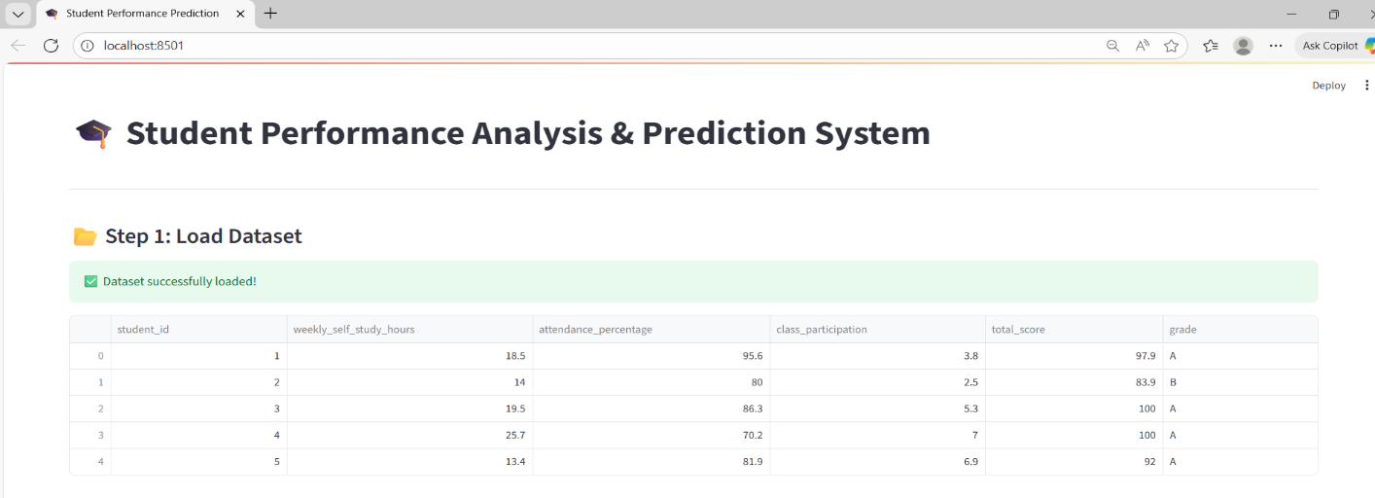
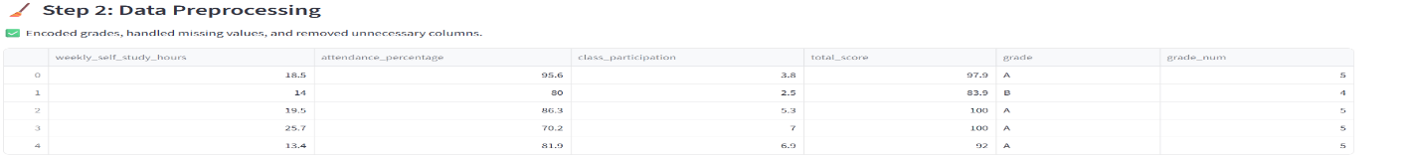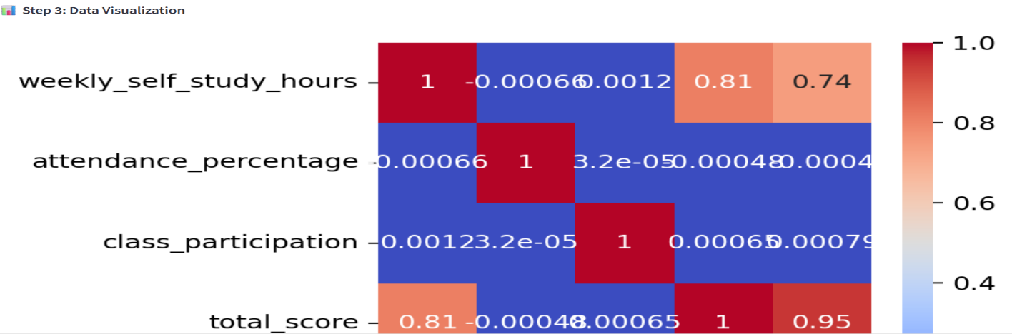
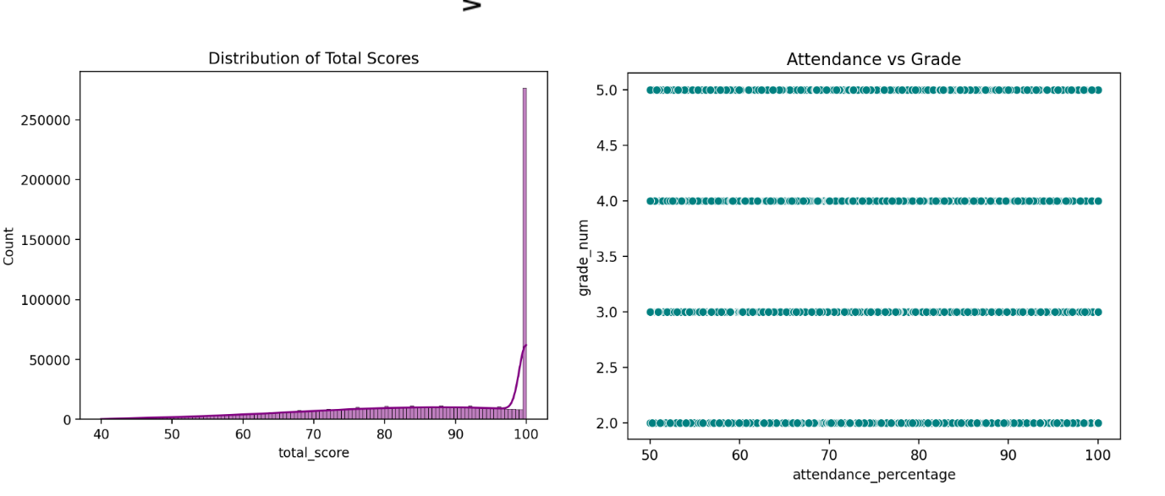
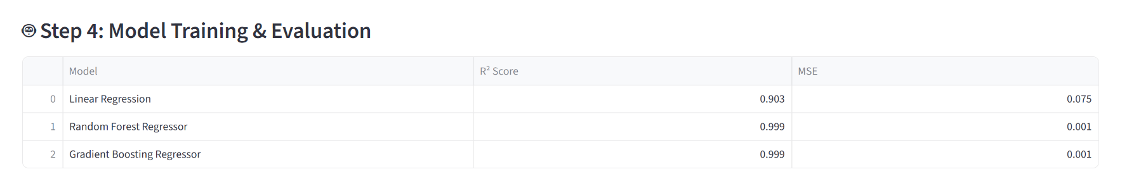
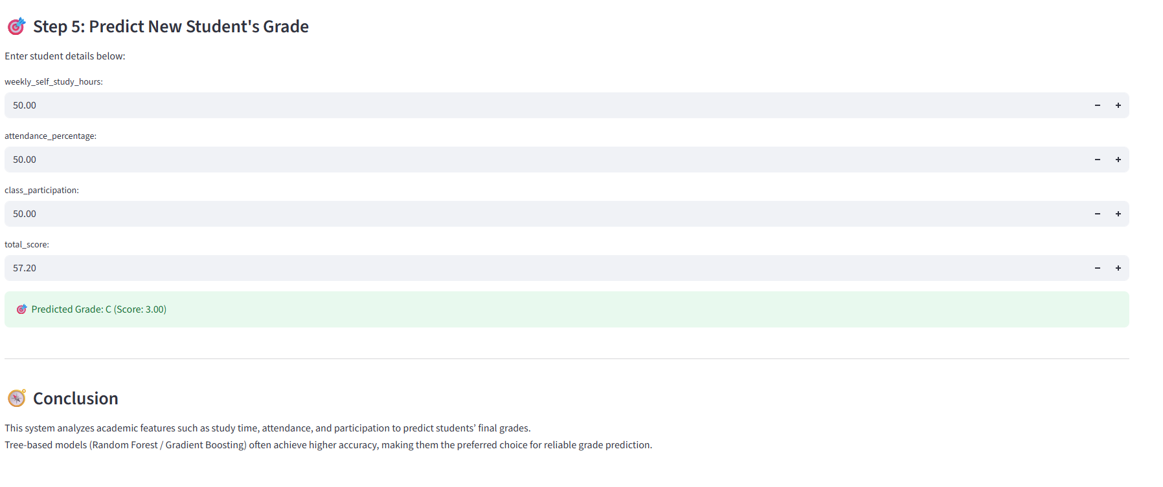
Code Explanatiom:
1.Project Overview
- The project predicts student academic performance using machine learning techniques.
- It analyzes key factors like study hours, attendance, participation, and previous scores.
- Helps educators identify at-risk students and provide timely support.

2. Data Collection
- Student data is collected from a dataset containing academic and personal features.
- Important features include attendance percentage, study time, class participation, assignments, and previous exam scores.

3. Data Preprocessing
- Grades are converted from letters (A, B, C, etc.) to numeric values for analysis.
- Missing or inconsistent data is handled to ensure accuracy.
- Irrelevant information (like student ID) is removed.
4. Data Visualization
- Correlation heatmaps are used to show relationships between features and grades.
- Histograms display score distributions.
- Scatter plots help visualize the relationship between key factors, e.g., attendance vs. grades.
5. Machine Learning Models
- Three models are used to predict grades:
  - Linear Regression – predicts grades based on linear relationships between features.
  - Random Forest Regressor – uses multiple decision trees to improve accuracy.
  - Gradient Boosting Regressor – sequentially improves predictions by learning from previous errors.
6. Model Training and Evaluation
- The dataset is split into training and testing sets.
- Each model is trained using historical data.
- Model performance is evaluated using metrics like R² Score and Mean Squared Error.
- The model with the highest accuracy is selected as the best-performing model.
7. Feature Importance
- For tree-based models, the contribution of each feature is calculated.
- Helps identify which factors (attendance, study hours, participation, etc.) most influence student grades.
- Provides actionable insights to teachers.
8. Predicting New Student Grades
- Users can input new student data (attendance, study time, participation, etc.).
- The system predicts the final grade for the student.
- The numeric prediction is converted back to a letter grade for easy interpretation.
9. Benefits of the System
- Provides accurate, data-driven predictions compared to manual evaluation.
- Allows early identification of weak students.
- Helps educators focus on students needing support.
- Reduces manual effort and time in performance evaluation.
- Makes academic assessment more objective and reliable.
8.Conclusion:
The Student Performance Analysis & Prediction System effectively predicts students’ academic performance using machine learning techniques. By analyzing factors like study hours, attendance, participation, and past scores, the system provides accurate predictions and identifies students who may need extra support. Tree-based models, such as Random Forest and Gradient Boosting, showed the highest accuracy in predicting final grades. This system helps educators make data-driven decisions, reduces manual evaluation effort, and allows timely intervention to improve student outcomes. Overall, it is a reliable, efficient, and objective tool for monitoring and enhancing academic performance.

9.Reference:

- UCI Machine Learning Repository : Student Performance Dataset.
https://archive.ics.uci.edu/ml/datasets/Student+Performance
- Scikit-learn Documentation : Machine Learning Library for Python.
https://scikit-learn.org/
- Seaborn and Matplotlib Documentation :Data Visualization Tools for Python.
https://seaborn.pydata.org/,https://matplotlib.org/
- IEEE Research Paper (2023) : Machine learning lfor Educational Data Analytics.
https://ieeexplore.ieee.org/
- Kaggle: Student Performance Data and Analysis Projects.
https://www.kaggle.com/

